**EGR 608 -Advanced Simulation  
Topology Optimization of Lower Control Arm**

**Pavan Badami**

**Susheelkumar C. S.**

**Sandesh Bhat**

**Jason Olson**

# PROBLEM STATEMENT

Structural safety of automotive suspension plays a critical role in vehicle stability and safety. Lower control arm not only supports entire weight of the vehicle but also controls coasting during travel. We propose to carry out linear stress analysis subjected to various simplified load cases. As well as, we plan to carry out topology optimization to reduce weight and increase the stiffness of the structure. The optimized part is smoothened and re-analyzed for validating the structural stability.

# ANALYSIS METHODOLOGY

A simple geometry resembling the Lower Control Arm (LCA) shape is modelled and utilized for the analyses. The following steps detail the analysis methodology briefly:-

1. A basic geometry of the Lower Control arm is analyzed with the given loads and boundary conditions, using both MSC Natran/Patran and ANSYS Workbench, linear structural performance.
2. The linear structural analysis provides us with the information on the Von-Mises stresses and deformation of the part under loading.
3. The in-built topology optimization feature of both the softwares are utilized to find an optimal geometry with the major objective to reduce the weight of the component.
4. The results from both the softwares are compared for 3 cases of weight reduction (10%, 15% and 20% mass reduction) and the final optimal solution/geometry of the part is modified to smooth out the sharp edges.
5. The modified parts are re-analyzed for linear structural performance to verify the optimized solution remain under the material yield stress value.

The control arm was assumed to have an isotropic material property and is made of structural steel with the properties mentioned in Table 1. This would ensure that the stress distribution and structural performance are in accordance with the load & boundary conditions.

|  |  |  |  |
| --- | --- | --- | --- |
| **Material** | **Young’s Modulus (Pa)** | **Poisson’s Ratio** | **Density (kg/m3)** |
| Structural Steel | 2.00E11 | 0.3 | 7850 |

Table 1: Material property details

# LOAD & BOUNDARY CONDITIONS

The component is subjected to loads in both vertical and horizontal direction, as the connection to the frame of the car bear the load from the engine and vehicle dynamics. Since the primary objective of the project is to find the optimized solution with reduced weight, the loading conditions were simplified, as shown in Figure___.

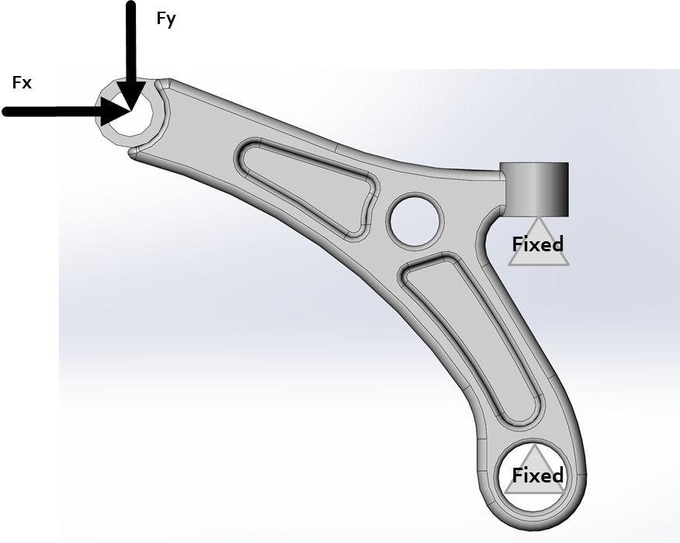

Fig 1. Control arm geometry

Both the inner cylindrical surfaces that are connected to the vehicle frame are assumed to be fixed and all the load are assumed to be acting on the inner cylindrical surface bolted to the tires, as shown in Figure 2.

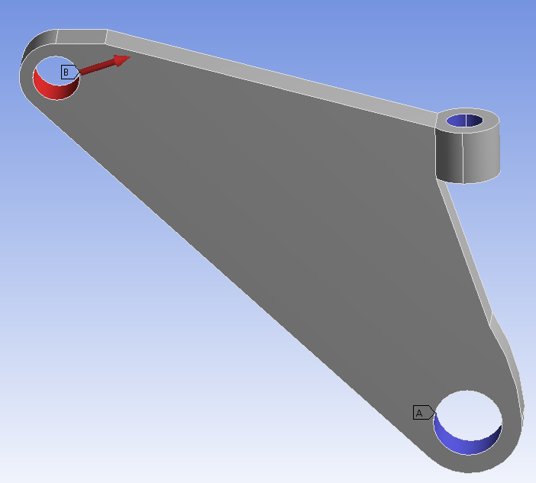 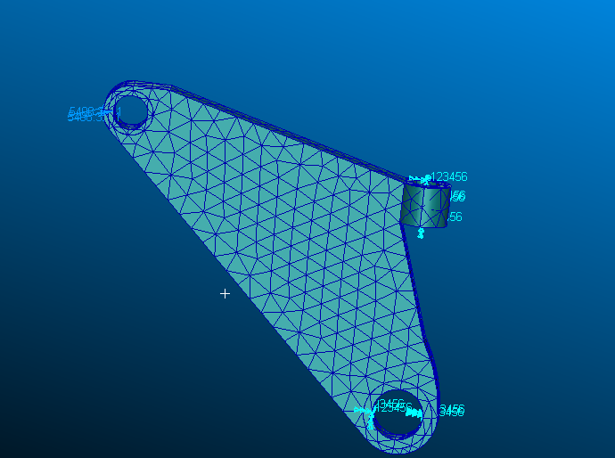

Fig 2. Loads on the control arm a) ANSYS b) PATRAN

There have been multiple analyses performed in the past for the structural integrity of LCA (Singh & Bhushan, 2012). The load and boundary conditions utilized for the analyses are indicated in Table 2.

Table 2: Load and boundary condition

|  |  |  |
| --- | --- | --- |
| **Load-Fx (N)** | **Load-Fy (N)** | **Constraints** |
| 5100 | -1800 | Fixed-Cylindrical Surfaces |

# MESH CONTROL

A standard adaptive mesh control with a minimum element edge length of 0.02 m, was used in ANSYS workbench to mesh the solid body with a default Tetrahedron elements, as indicated in Figure 3. As shown the adaptive control consider the cylindrical surfaces be meshed uniformly along the periphery and match them with the rest of solid part meshing. A total of 3631 Nodes and 1837 Elements are created in this process. While in PATRAN we adopted TET10 Mesh with global edge length 0.01 having 2796 elements 5298 nodes.

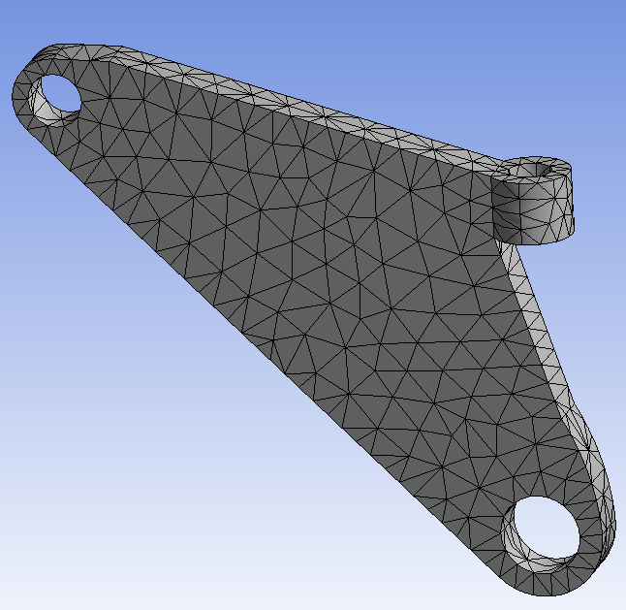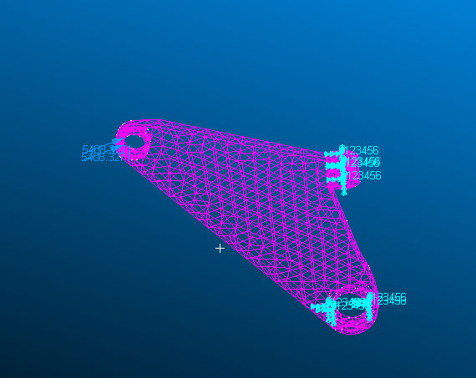

Fig 3. Meshed geometry in a) ANSYS and b) Patran

# RESULTS & OBSERVATIONS

## Initial Linear Static Analysis

The linear static structural analysis for the simplified component under the above mentioned load and boundary conditions was performed and the results for the Equivalent Von Mises Stress and Total Deformation from ANSYS/NASTRAN are indicated below in Figure 4 a) and b). Maximum stress value obtained using NASTRAN is 2.09E07 N/m2 and maximum displacement 2.45E-05 m

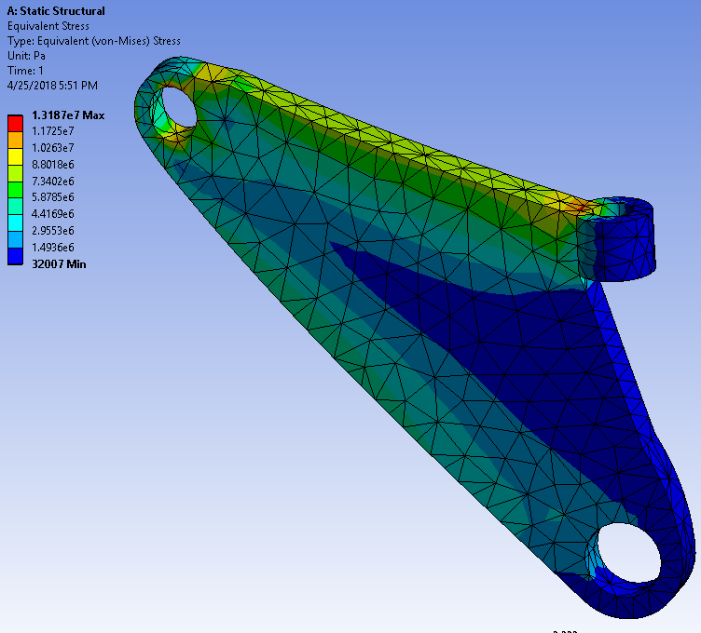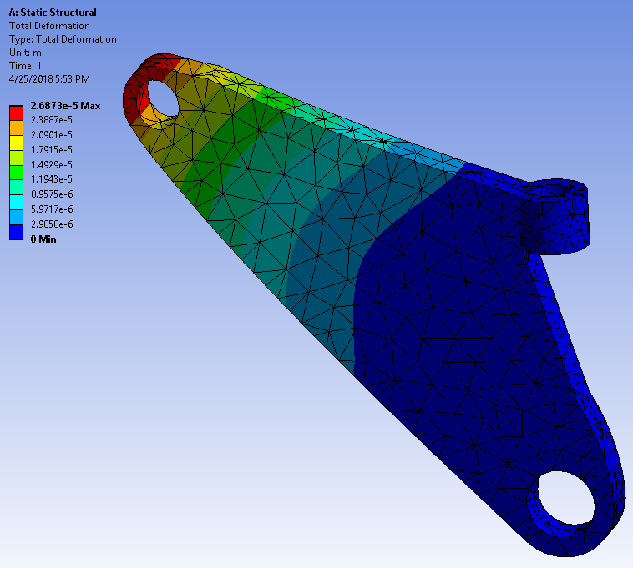

Fig 4 a) Displacement and Stress contour using ANSYS

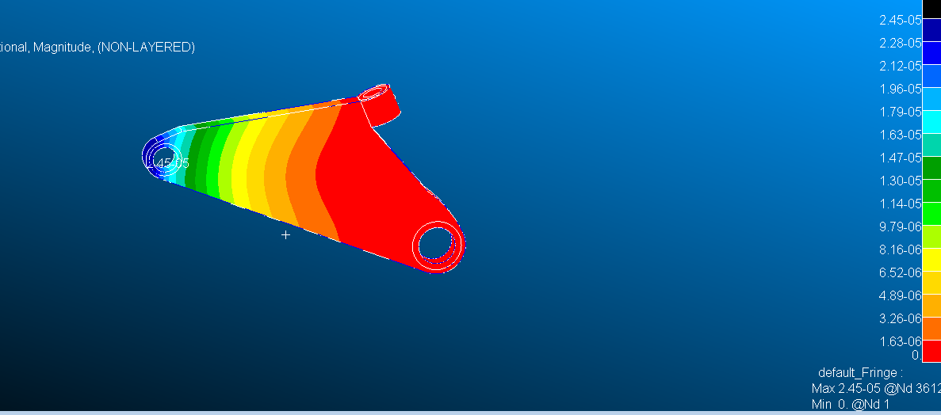

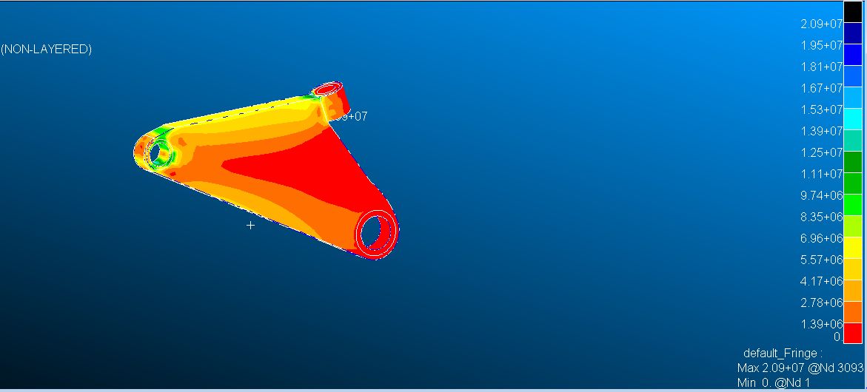

Fig 4 b) Displacement and Stress contour using NASTRAN

## TOPOLOGY OPTIMIZATION IN NASTRAN

Nastran follows density/young’s modulus based approach (i.e. power law) E=Eo xp (p is the penalty parameter.)

On selecting Toptomize under action drop box we can set the mass target constrain based on how much mass you need to reduce from the structure. We can initial design condition and other control parameters under optimization and control parameters. XINT initial value defined to match mass constrain. XLB is used to define lower bound to prevent singularity of the stiffness matrix .DELXV fractional changes allowed for design variable. Penalty factor used in the design relation between design variables and young’s modulus.

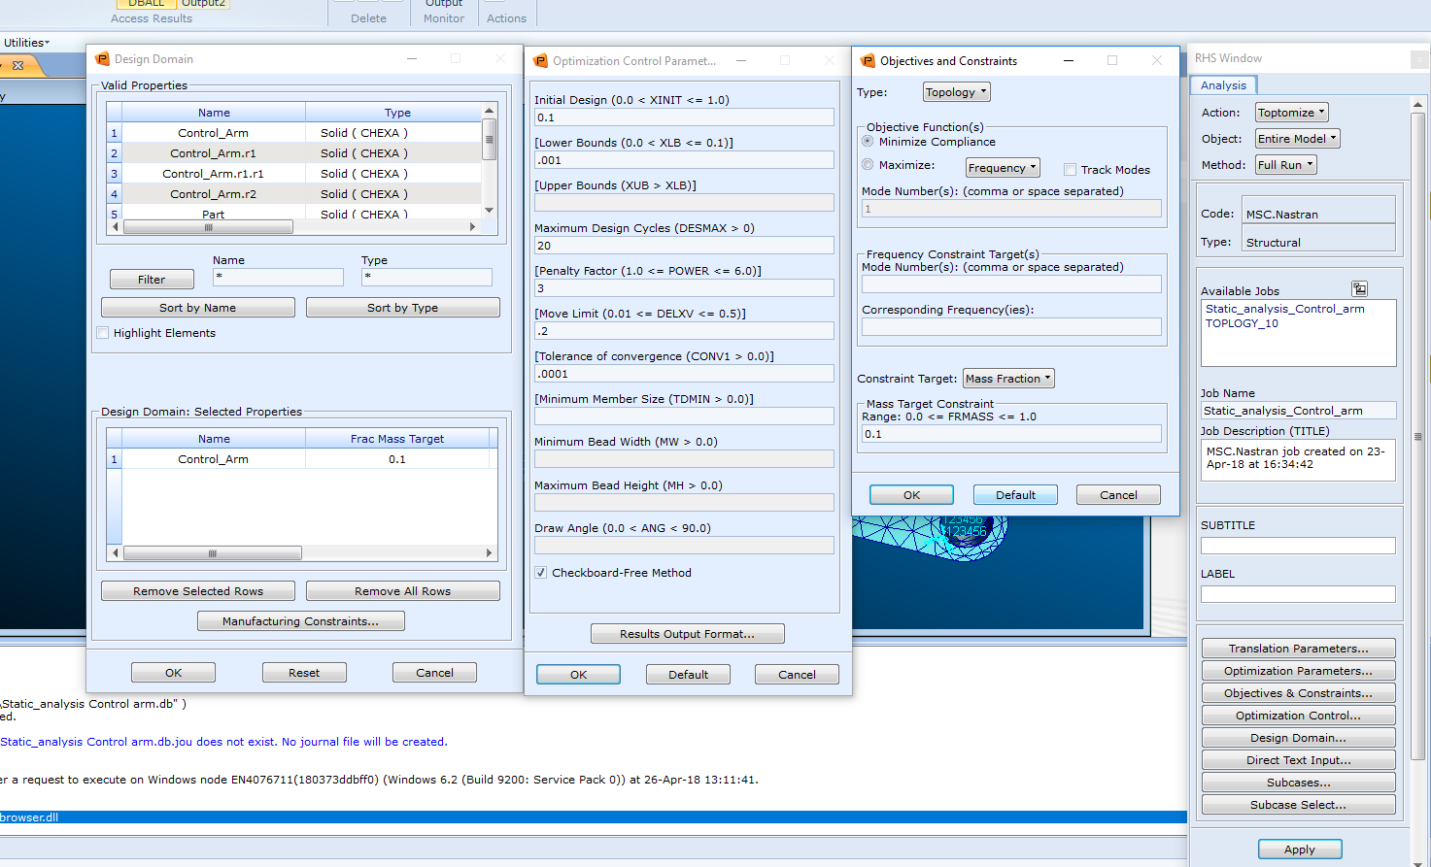

## Fig 5 Topomize control in NASTRAN

## Topology Optimization-Case I (10% reduction)

The results from the linear structural analysis are made use by the Topology Optimization feature of both the softwares (MSC Patran & ANSYS Workbench) to identify the least significant or least stressed element. The objective of the optimization module was set to minimize compliance and the response constraint was set to 90% mass retention (as shown in Figure). It was allowed to run a maximum of 500 iteration to attain a convergence accuracy of 0.1%. Additionally all the constrained surface were excluded from the optimization region

In ANSYS Workbench the optimization module performed 8 iterations and the output results are indicated below in Figure __

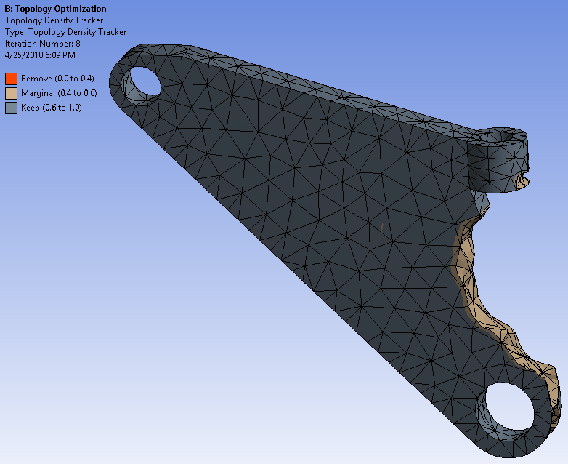 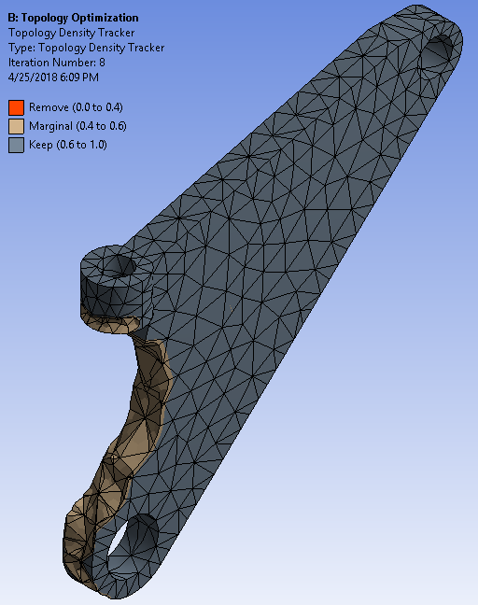

Fig 6. 10 % mass reduction topology optimization using ANSYS

In MSC Patran the optimization module performed 25 design cycles and the output results are indicated below in Figure 7__

*Pavan Part-1(Top Opt-Part I)*

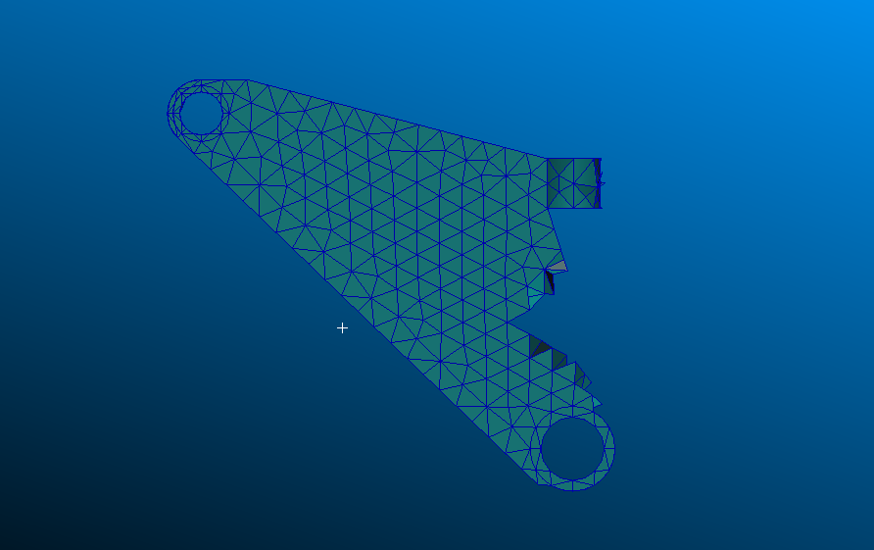

Fig 7 10 % mass reduction topology optimization using NASTRAN

These optimized parts were exported and repaired to smooth the sharp edges and corners (as shown in Figure___) to validate the linear static performance and to verify the maximum stresses are below the material yield stress value.

*Jason Part-1*

## Linear Static Analysis after 10% mass reduction

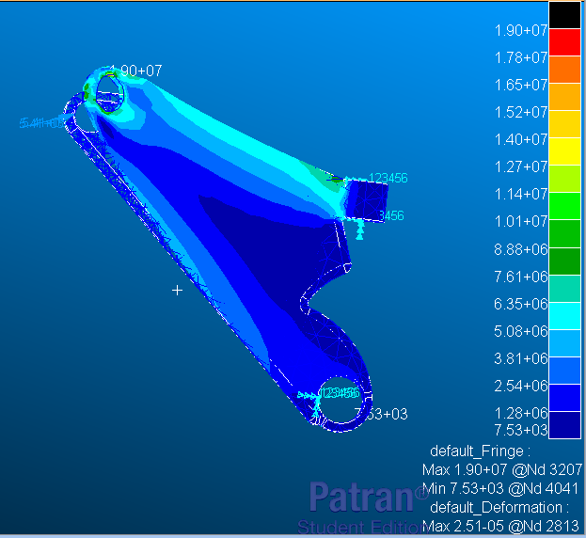

Fig __ Linear Static Analysis of the 10 % reduced Control arm

The linear static analysis was run with an edge length of 0.06, 2416 elements, and 4608 nodes. The results of the analysis are as follows: maximum displacement = 2.51 e-5 m and maximum stress = 1.9 e7 N/m^2. The results (as shown in figure__) are coherent with the initial analysis results obtained in figure 4(b).

## Topology Optimization-Case II (15% reduction)

The optimization module was now set to retain 85% of the initial simplified part. All the other parameters was kept the same as Case I. In ANSYS Workbench the optimization module performed 9 iterations and the output results are indicated below in Figure __

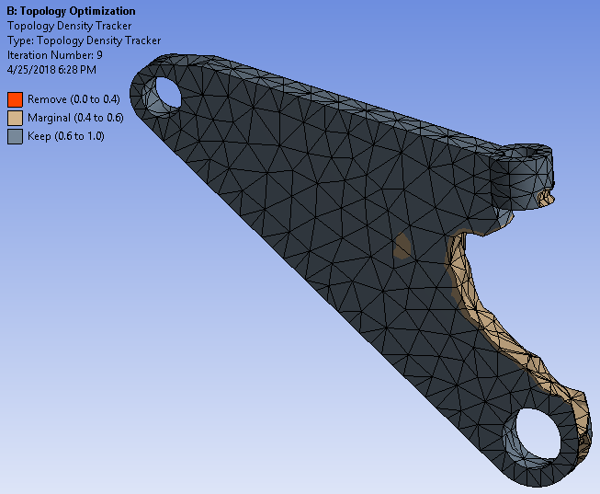 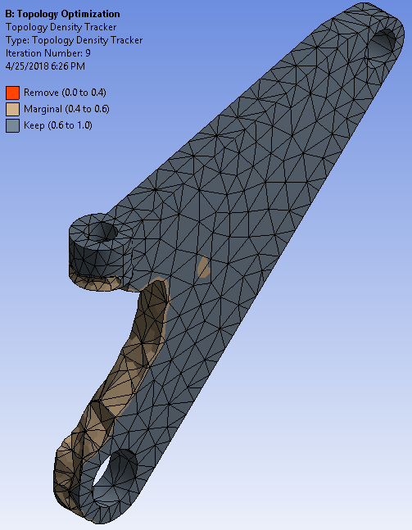

In MSC Nastran the optimization module performed ___ iterations and the output results are indicated below in Figure __

*Pavan Part-2 (Top Opt-Part II)*

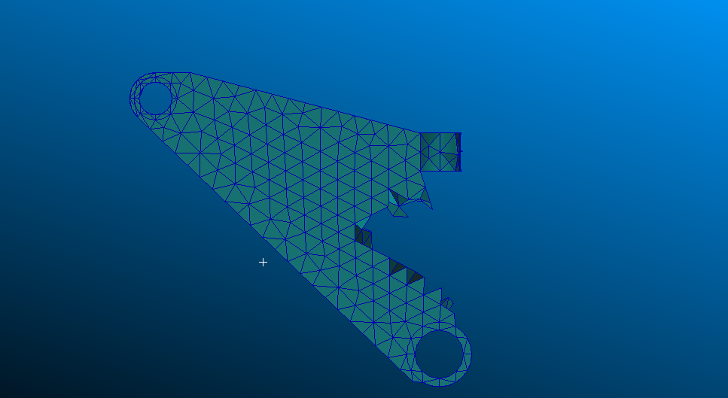

Fig 15% mass reduction topology optimization using NASTRAN

These optimized parts were again exported and repaired to smooth the sharp edges and corners (as shown in Figure___) to validate the linear static performance and to verify the maximum stresses are below the material yield stress value.

*Jason Part-2*

## Linear Static Analysis after 15% mass reduction

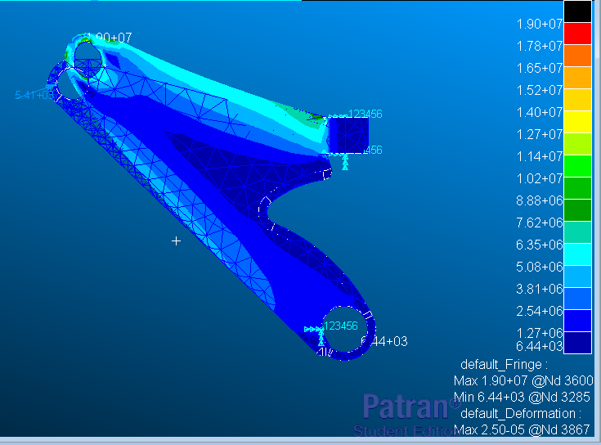

Fig __ Linear Static Analysis of the 15 % reduced Control arm

The linear static analysis was run with an edge length of 0.06, 2485 elements, and 4707 nodes. The results of the analysis are as follows: maximum displacement = 2.5 e-5 m and maximum stress = 1.9e7 N/m^2. The results (as shown in figure__) are coherent with the initial analysis results obtained in figure 4(b).

## Topology Optimization-Case III (20% reduction)

The optimization module was now set to retain 80% of the initial simplified part. All the other parameters was kept the same as Case I and Case II. In ANSYS Workbench the optimization module performed 10 iterations and the output results are indicated below in Figure __

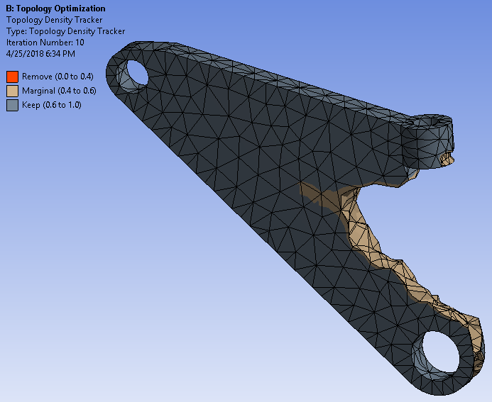 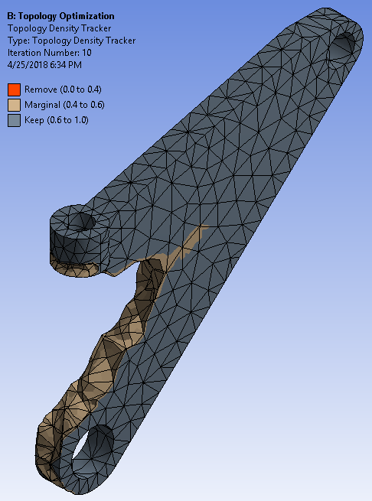

In MSC Patran the optimization module performed ___ iterations and the output results are indicated below in Figure __

*Pavan Part-3 (Top Opt-Part III)*

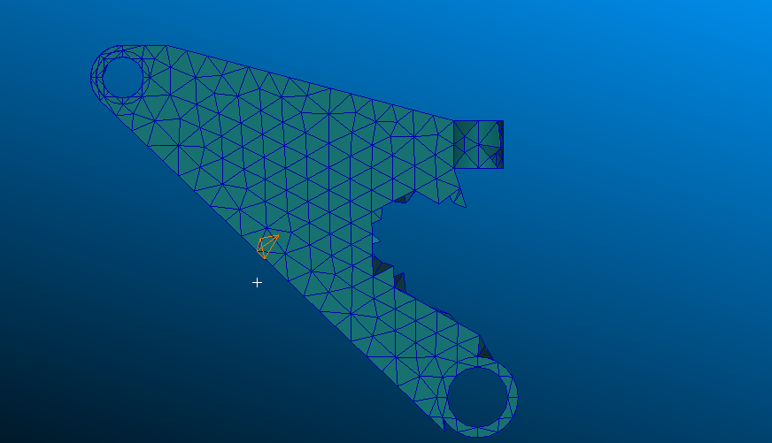

*Fig 15% mass reduction topology optimization using NASTRAN*

These optimized parts were again exported and repaired to smooth the sharp edges and corners (as shown in Figure___) to validate the linear static performance and to verify the maximum stresses are below the material yield stress value.

*Jason Part-3*

## Linear Static Analysis after 20% mass reduction

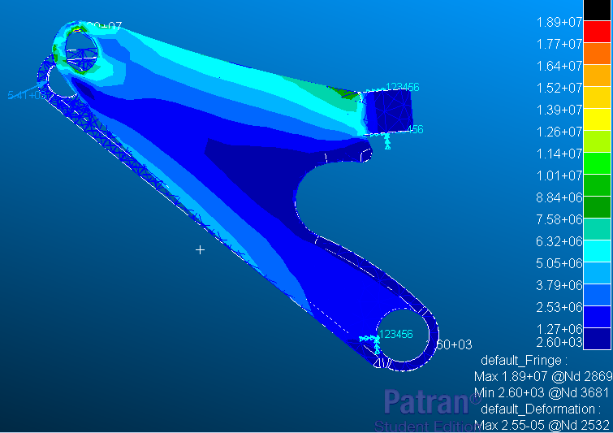

Fig __ Linear Static Analysis of the 20 % reduced Control arm

The linear static analysis was run with an edge length of 0.06, 2177 elements, and 4181 nodes. The results of the analysis are as follows: maximum displacement = 2.55 e-5 m and maximum stress = 1.89e7 N/m^2. The results (as shown in figure__) are coherent with the initial analysis results obtained in figure 4(b).

# CONCLUSIONS & FUTURE WORK

It was observed that even though the same loads and boundary conditions were applied to the component using both the softwares, there were minor variation in the stress and deformation values in the linear static analysis. It might get us closer results by utilizing an RBE3 node at the cylindrical surface center and connecting all the inner cylindrical surface node to the center node. Also it would need the load be applied to the center node. This should distribute load evenly to the cylindrical surface irrespective of the software.

In case of optimization module, we got similar results from both the softwares. In case of MSC Patran, an additional solid block was required to be modeled into the geometry to avoid the contact surfaces of boundary conditions/constraints being removed by the optimization module for weight reduction.

The accuracy of convergence of Patran (0.001%) is much higher as compared to that of ANSYS workbench (0.1%) for the similar iteration/computational time.

# REFERENCES

Singh, H., & Bhushan, G. (2012). *Finite Element Analysis of a Front Lower Control Arm of LCV Using Radioss Linear.*